Contents
Introductory Statement | Page 1
School Information | Page 1
Rationale | Page 1
Belief Statement | Page 1
Aims of the Policy | Page 2
Roles and Responsibilities | Page 2
Identifying Pupils with Additional Needs | Page 6
Information Gathering and Assessment | Page 12
Inventory of Test Materials | Page 12
Prevention and Early Intervention Strategies | Page 13
Meeting the Needs and Allocating Resources | Page 13
Timetabling | Page 15
Tracking, recording and reviewing progress | Page 15
Health and Safety Issues | Page 18
Supervision/Child Protection | Page 18
Addendum Due to COVID-19 | Page 18
Ratification and Communication | Page 19
Implementation and Review | Page 19
1
Additional Support Policy Support for All
September 2020

BOSTON National School

Introductory Statement
Our SEN policy was reviewed by the School Staff and Board of Management in September 2020. This policy is in accordance with Circular No 0013/2017. It was circulated to staff and Board of Management members in May 2019 and finalised in June 2019. This review was carried out to assess the need for changes due to COVID-19.

School Information
Boston National School, situated in the townland of Drumnadeevna has been educating children in the current school building since 1873,under the patronage of the Catholic Church. We endeavour to create a positive and inclusive atmosphere that respects all children, regardless of their religious, social, cultural background or special educational needs. We have currently a high population of EAL families in our school. Given the demographics of our school population, our provision of support and timetables are regularly reviewed.

Rationale
The purpose of this policy is to:
- provide practical guidance to staff, parents and other interested parties about our SEN procedures and practices.
- outline the framework for addressing additional needs in our school.
- comply with legislation (Education Act 1998, Equal Status Act, 2000)
- fulfil DES circular 0013/17 -Circular to the Management Authorities of all Mainstream Primary Schools; Special Education Teaching Allocation,and new 2017 Guidelines for Primary Schools: Supporting Pupils with Special Educational Needs in Mainstream Schools).

Belief Statement

Our school is dedicated to the implementation of an effective system for meeting the needs of all our pupils in accordance with our mission statement, the resources provided by the DES and the Board of Management.

We believe that all our children have a right to an education, which is appropriate to their individual needs. We strive to ensure that all our children feel that they are a valued part of our school community. We are fully committed to the principle of inclusion. This policy aims to enable children with Special Education Needs (SEN) and children whose first language is not English, to become fully integrated members of our school community. This will be achieved by careful consideration of the needs of each child and by either modifying the environment, activities or by providing support that will help the child to participate in them. Our aim is to achieve this as best as we can with the resources at our disposal.

Aims of the Policy
This policy aims to outline our procedures and practices of how we:
- identify additional needs that our pupils may have
- allocate resources to effectively meet the needs of children with additional needs
- divide the roles and responsibilities among our school community in relation to pupils with additional needs
- track, monitor, review and report on the progress of children with additional needs
- communicate information between the SET team, principal, staff and parents/guardians

Roles and Responsibilities
Board of Management:
The BOM oversees the development, implementation and review of school policy on SEN. They also ensure that adequate classroom accommodation, secure storage space and effective teaching resources are provided, where possible.

Principal:
The Learning Support Guidelines (2000, P.39) outlined the principal has overall responsibility for SEN procedures and practices in the school. The new allocation model states the principal’s leadership role is central and includes the following;
The school principal should
- Implement and monitor the school’s Additional Needs policy on an on-going basis.
- Assign staff strategically to teaching roles, including special education(SET) roles
- Co-ordinate teachers’ work to ensure continuity of provision for all pupils
- Ensure that whole-school procedures are established to facilitate the effective involvement of parents, pupils and external professionals/agencies
- Ensure that effective systems are implemented to identify pupils’ needs and that progress is monitored methodically
- Facilitate the continuing professional development of all teachers in relation to education of pupils with special educational needs, and ensure that all school staff (class teachers, special education teachers and special needs assistants) are clear regarding their roles and responsibilities in this area
- assign responsibility for coordinatingadditional support to an identified teacher(i.e SENCO)
- communicate with the SENO (Special Education Needs Organiser)
- oversee a whole school assessment and screening programme
- allocate time within the school timetable for the SET teacher/team to plan and consult with teachers and parents as is necessary
- inform staff about external agencies and provide information on continuing professional development in the area of SET
- meet with parents regarding any concerns about their child and update them regarding their progress

SEN Co-ordinator:
SEN co-ordinator (SENCO) should:
- communicate with the principal in relation to SEN matters on an on-going basis
- liaise with external agencies about the provision for pupils with additional needs
- liaise with the NEPS psychologist, the SET team and class teachers to prioritise children for psychological assessments (NEPS)
- liaise with SEN Class Co-ordinators to identify, support and monitor children with additional needs
- co-ordinate regular SET team planning meetings to ensure effective communication and support for children with additional needs
- collaborate with the SET team in creating timetables for additional support
- meet with parents regarding any concerns about their child, advise parents on procedures for availing of special needs services and update them regarding their progress
- co-ordinate the whole-school standardised testing at each class level
- co-ordinate the screening of pupils for additional support, using the results of standardised tests
- select children for external diagnostic assessment, where parental permission has been sought and granted
- oversee the tracking system of test results on password-protected Aladdin software to monitor the progress of pupils
- maintain lists of pupils who are receiving additional support

Class Teacher:
Class teachershave primary responsibility for the teaching and learning of all pupils in his/her class, including those selected for additional support. They should
- implement teaching programmes which optimise the learning of all pupils and, to the greatest extent possible, prevent the emergence of learning difficulties
- create a positive learning environment within the classroom
- differentiate teaching strategies, approaches and expectations to the range of experiences, abilities, needs and learning styles in their class
- administer and correct standardised tests of achievement in literacy and numeracy, following the school's guidelines
- discuss outcomes of standardised testing with SENCO to assist in the selection of children for supplementary teaching
- meet with parents regarding any concerns about their child and update them regarding their progress
- gather information and assess children presenting with needs to inform teaching and learning using the Continuum of Support
- open a Pupil Support File once additional needs have been identified and require classroom support
- develop classroom support plans for children in receipt of Classroom Support
- collaborate with staff to develop Individual Profile and Learning Programmes(IPLP)or Group Profile and Learning Programmes (GPLP) for each pupil in receipt of School Support
- meet with Special Education Teachers, parents/guardians and other staff members to identify priority learning goals for each pupil in receipt of School Support Plus and who require an Individual Education Plan
- collaborate with Special Education Teachers and relevant staff to develop an Individual Education Plan (IEP) for each pupil in receipt of School Support Plus
- regularly meet with Special Education Teachers, relevant staff to review IEPs
- meet regularly with Special Education Teachers, relevant staff and parents to review IEP
- where applicable, collaborate with theSET team regarding teaching aims and activities for team teaching
- adjust the class timetable to ensure that children in receipt of supplementary teaching will not be absent for the same subject/activity during each session, where possible
- co-ordinate the role and responsibilities of the SNA in relation to the needs of pupils with SEN within the class(es) to which they are assigned

Special Education Teacher (SET)
The SET teacher should:
- familiarise themselves with a wide range of teaching approaches, methodologies and resources to cater for particular learning styles and to meet a variety of need
- assist in the implementation of a broad range of whole school strategies aimed at prevention and early intervention
- collaboratively develop Individual Profile and Learning Programmes (IPLP) for each pupil selected for school support teaching with class teachers and other staff
- meet with class Teachers, parents/guardians and other staff members to identify priority learning goals for each pupil in receipt of School Support Plus and who require an Individual Education Plan (IEP)
- collaborate with class teachers and relevant staff to develop an Individual Education Plan for each pupil in receipt of School Support Plus
- regularly meet with class teachers, relevant staff to review IEPs
- meet twice a year with class teachers, relevant staff and parents to review IEP
- update and maintain planning and progress records for each individual or group of pupils in receipt of school support
- provide supplementary teaching for literacy and numeracy on a withdrawal and in-class support basis
- support whole-school procedures for screening
- administer and interpret diagnostic tests and inform class teachers and parents of the outcomes
- meet with parents regarding any concerns about their child and update them regarding their progress
- co-ordinate class groups and offer advice and support to class teachers regarding pupils on their caseload
- discuss the needs and progress of children on their caseload at planning meetings

Special Needs Assistants: When / If applicable
The duties of the SNA carried out according to the guidelines for Special Needs Assistants from the Department of Education and Skills and under the direction of the principal/class teachers, the SNA will meet the care needs of the SEN pupils to which they have been assigned. (Circular 10/76).
The SNA should
- support the needs of pupils in effectively accessing the curriculumby following a written plan
- contribute to the quality of care and welfare of the pupils
- support learning and teaching in the classroom
- attend, where possible, training courses/workshops provided by the BOM
- attend IEP meetings and/or meetings with relevant professionals, when necessary
- ensure the safety of the SEN pupils in the schoolyard, and be present for the duration of the yard breaks along with the teachers on duty
- maintain a record of support provided to their SEN pupil
- accompany SEN pupil to supplementary lessons when appropriate

Parents/Guardians:
Collaboration and sharing of relevant information between home and school are essential elements of our SEN policy. Parents/Guardians through their unique knowledge of their own childrenhave much to contribute to their child’s learning.
Parent/Guardian should:
- share any information, reports or reports pending from health professionals, and/or concerns regarding their child’s development. Copies of professional reports should be provided to the school at the enrolment stage
- support the work of the school and keep the class teacher informed of the progress and challenges they observe in their child’s learning
- attend meetings arranged by the class teacher or SET team/Teacher
- support the targets outlined in their child’s support plans and engage in all suggested home-based activities
- inform the post-primary school of their child’s needs, at thetransition stage
Pupils:
Pupils who are in receipt of supplementary teaching should, as appropriate:
- become familiar with the targets that have been set for them
- develop ‘ownership’ of the skills and strategies that are taught during supplementary teaching and learn to apply these learning strategies and skills to improve their own learning
- contribute to the evaluation of their progress by participating in appropriate assessment activities, including self-assessment

Identifying Pupils with Additional Needs

Continuum of Support
We use the Continuum of Support Framework set out by the Department of Education to identify and support children with additional needs. Like this framework, we recognise that special educational needs occur along a continuum, ranging from mild to severe, and from transient to long-term and that pupils require different levels of support depending on their identified additional needs. By using this framework, it helps us implement a staged approach to ensure that our support and interventions are incremental, moving from class-based interventions to more intensive and individualised support, and are informed by careful monitoring of progress.

The Continuum of Support is a problem-solving model of assessment and intervention that enables us to gather and analyse data, as well as to plan and review the progress of individual pupils.

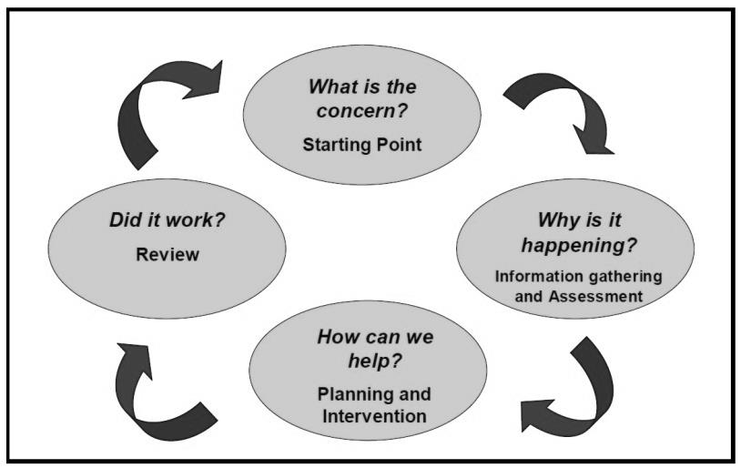
This problem-solving process is illustrated as follows:

Identification of educational needs is central to our policy and the new allocation model. By using the Continuum of Support framework, we can identify pupils’ educational needs, to include academic, social and emotional needs, as well as needs associated with physical, sensory, language and communication difficulties. This, in turn, allows us to identify and respond to needs in a flexible way.
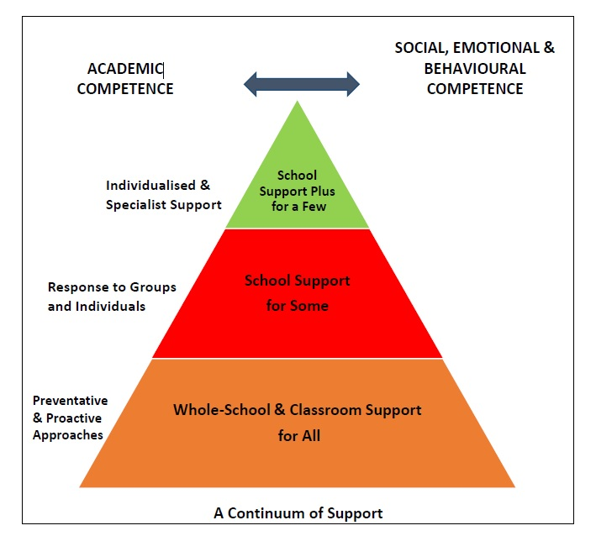
The Continuum of Support suggests the following levels of support:

STAGE 1 CLASSROOM SUPPORT
Classroom Support is the most common, and typically the first response to emergingneeds. It is a response for pupils who have distinct or individual educational needs and whorequire approaches to learning and/or behaviour which are additional to or different fromthose required by other pupils in their class.Problem-solving at this level typically begins when a parent or teacher has concerns about anindividual pupil. The teacher, School Co-ordinator and parents discuss the nature of the problem and considerstrategies which may be effective. Classroom Support incorporates the simple, informalproblem-solving approaches commonly used by class teachers to support emerging needs.

STAGE 2 SCHOOL SUPPORT
In some cases, interventions at classroom support level are not enough to fully meet the pupil’sspecial educational needs. School Support may, therefore, be required.The class teacher needsto involve the Special Education Teacher/ Team(SET Team)in the problem-solving process at this point andit involves more systematic gathering of information and the development and monitoring of aSchool Support Plan.

STAGE 3 SCHOOL SUPPORT PLUS
If a pupil’s special educational needs are severe and/or persistent, they are likely to need intensive support. School Support Plus will generally involve personnel outside the school team in the problem solving, assessment and intervention process. However, the informationfrom Classroom and School Support work will provide the starting point for problem-solvingat this level. Classroom support and school support will continue to be an important elementof his/her individual education plan.

The flow diagrams below outline how we gather information to identify needs and support children with additional needs. A more comprehensive explanation of each stage can be in the Continuum of Support – Guidelines for teachers
https://www.education.ie/en/Schools-Colleges/Services/National-Educational-Psychological-Service-NEPS-/neps_special_needs_guidelines.pdf

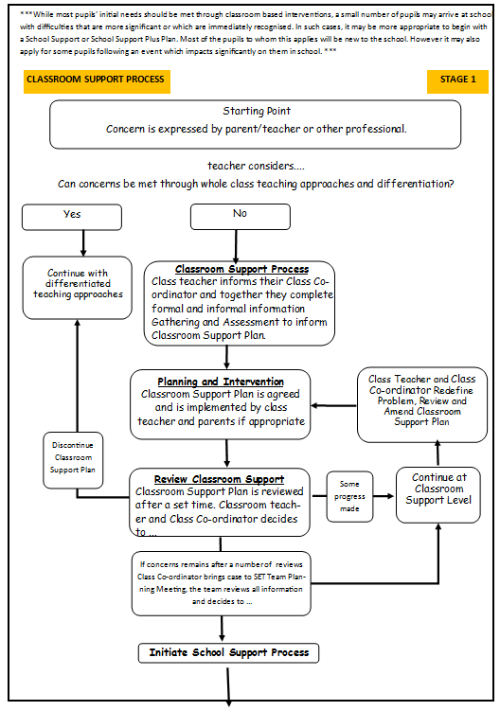
* adapted from NEPS Continuum of Support. For more detailed steps see page 12 - 15of the continuum of support - Guidelines for teachers
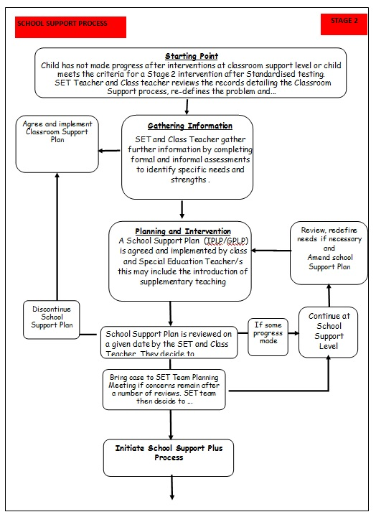
* adapted from NEPS Continuum of Support. For more detailed steps see page 22 - 25 of the continuum of support - Guidelines for teachers
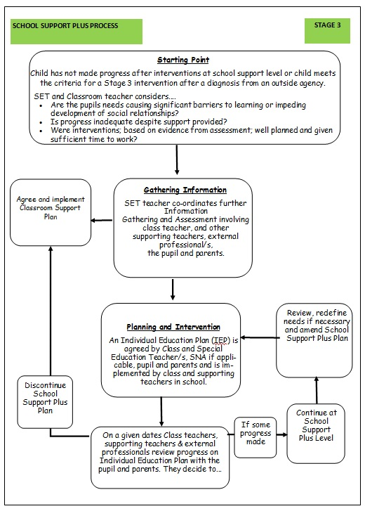
* adapted from NEPS Continuum of Support. For more detailed steps see page 32 - 35 of the continuum of support - Guidelines for teachers
Information Gathering and Assessment
Assessment is part of what a class teacher does on a daily basis for all children. Some methods include self-assessment, questioning, teacher observation, portfolios of work and teacher-designed tasks and tests. The information gathered enables the teacher to plan learning experiences based on the appropriate objectives from the curriculum.

In order to identify pupils who may require supplementary teaching, screening; including standardised testing, is carried out in all classes annually and further diagnostic testing may need to take place. The information gathered from these formal assessments is then used to inform decisions for support and pupil’s support plans (CSP, IPLP/GPLP and IEP)

Assessment and Screening Tests:
In our school we carry out the following assessment procedures:
- Junior Infants: Observation, Checklists, BPVS - on pupil’s with English as a 1st language, EAL tests for Children with English as a 2nd language
- Senior Infants: Observation, Checklists, MIST, B.I.A.P.
- 1st class: Observation, Checklists, Drumcondra Maths & English
- 2nd class: Observation, Checklists Drumcondra Maths & English.
- 3rd class: Observation, Checklists, Drumcondra Maths & English. CAT 4/Dyslexia
- 4th class Observation, Checklists, Drumcondra Maths & English.
- 5th class: Observation, Checklists, Drumcondra Maths & Englishand CAT4/dyslexia screening, where necessary.
- 6th class: Observation, Checklists, Drumcondra Maths & English.

As a school, we also carry out further testing with children scoring on or below the 16th percentile in the Drumcondra Maths and Englishin classes 2nd- 6th if they are new pupils to the school and were not tested in 2nd Class.

We continually review the assessment and screening tests that we use in order to balance the needs of our pupils and the need to provide information for appropriate support. Therefore we may deviate from the above list prior to the review date.

Inventory of Test Materials
Screening Tests

- Belfield Infant Assessment Profile (BIAP)
- Middle Infant Screening Test (MIST)
- Drumcondra Maths
- Words Their Way (optional)

- Drumcondra English
- CAT4 - dyslexia screening
- Spelling Screening Test
- Primary Assessment Kit (EAL; Juniors – First) / Cambridge English

- Dyslexia Screening Test

Diagnostic Tests
In our school the following tests are available for administration:
- Jackson Phonics Test  - Renfrew  - BPVS  - Maths Test Tracker | - York Assessment of Reading for Comprehension (YARC)  - SWRT
Early Intervention Strategies
Our strategies for preventing learning difficulties include:
- The development of agreed approaches to the teaching of Literacy and Numeracy in orderto ensure progression and continuity from class to class.
- Provision of additional support in language development and any relevant early literacy and mathematical skills to pupils who need it.
- Ongoing structured observation and assessment of the language, literacy and numeracy skills of pupils in the infant classes to facilitate early identification of possible learning difficulties.
- Close collaboration and consultation between the Infant Teacher and the SET teacher/team.
- Promotion of literacy e.g. Print-rich environment, DEAR(Drop Everything and Read),
- Promotion of Numeracy e.g. Ready Set Go Maths, Hands-on approach,
- Parental involvement in promoting literacy and numeracy e.g. Homework Policy Guidelines for Parents.
- Differentiation - adapting the learning environment.
- In-class support from theSET team.
- Power Hour/Team Teaching/Aistear.
- Withdrawing individuals/groups.

Meeting the Needs and Allocating Resources
Once pupils needs have been identified, Special Education Teachers (SETs)are deployed to address these needs as required. We deploy SETs in a variety of ways in order to effectively meet pupils’ needs.We aim to strike a balance between in-class support, group and individual support while ensuring that the needs of children with additional needs are met inclusively.

Importantly, the level and type of support reflect the specific targets of individual pupils as set out in their support plans and are informed by careful monitoring and review of progress. In this way, following a period of intervention, some pupils may no longer require additional teaching supports; some may require the same level, while others may require more intensive supports.

In planning the allocation of additional teaching supports, the over-riding principle is that resources are deployed to address the identified needs of pupils. Importantly, those with the highest level of need should have access to the greatest level of support. We consider methodologies best suited to promoting meaningful inclusion such as differentiation, heterogeneous grouping, team-teaching and small group teaching. In addition to literacy and numeracy difficulties, many pupils will have specific needs in such areas as oral language, social interaction, behaviour, emotional development, motor skills and application to learning.

We cross-reference the needs of pupils at School Support and School Support Plus levels and consider common needs that can be met by grouping, to ensure effective and efficient teaching and learning approaches.

SELECTION PROCESS FOR ALLOCATING ADDITIONAL TEACHING SUPPORT
Stage 3 School Support Plus | - Children with identified complex needs by an external professional such as a  - Physical Disability  - Hearing Impairment  - Visual Impairment  - Emotional Disturbance  - Moderate General Learning Disability  - Severe/Profound General Learning Disability  - Autistic Spectrum Disorder  - Assessed Syndrome  - Specific Speech and Language Disorder/Impairment | Individual Education Plans | Type of Support  In-Class Support  Team-Teaching  Group Withdrawal  Individual Withdrawal  Personnel  SET teacher  Class Teacher  Outside Agencies
Stage 2 School Support | - Prevention and Early Intervention Programs (Aistear, Infant Activities and Power Hour – Whole School Approach)  - Children in JI & SI whom English is an additional language or children whom English is an additional language newly arrived in Ireland in 1st – 6th  - Children on or under the 16th Percentile in Literacy Standardised Tests (spaces allocated according to need)  - Children with an identified need assessed by external professionals who are not on or below the 12th percentile in Literacy such as  - Borderline Mild General Learning Disability  - Mild General Learning Disability  - Specific Learning Disability  - Attention Deficit Disorder/ Attention Deficit Hyperactivity Disorder  - Children on or under the 16th Percentile in Drumcondra English  - Children with a identified need by external professionals who are not on or below the 16th percentile in Numeracy  - Borderline Mild General Learning Disability  - Mild General Learning Disability  - Specific Learning Disability  - Attention Deficit Disorder/ Attention Deficit Hyperactivity Disorder  - Children who have not made adequate progress after interventions at Stage 1  - Children in 1st – 6th who have not made adequate progress after EAL interventions | Group or Individual Profile and Learning Programme | Type of Support  In-Class Support  Team-Teaching  Group Withdrawal  Individual Withdrawal  Personnel  SET teacher  Class Teacher

Timetabling
When drawing up timetables it is important to remember that:

- timetables should be continually reviewed
- children should not miss the same subject each time they are withdrawn, if possible
- interruptions to classes/classrooms should be kept to a minimum.

Tracking, recording and reviewing progress

Provision for pupils with special educational needs is enhanced through clear identification processes and careful planning of interventions to address academic and/or personal and social development needs. Identification of needs, planning, target-setting and monitoring of outcomes are essential elements of an integrated and collaborative problem-solving process.

Student Support File

We use a Student Support File to plan interventions and to track a pupil’s pathway through the Continuum of Support. It facilitates us in documenting progress and needs over time and assists us in providing an appropriate level of support to pupils, in line with their level of need. Our Student Support File is based on the NEPS template and is stored on the school server/ locked cabinet. All support files should include:
- Cover sheet with pupil’s details
- A timeline of actions
- Record of support received
- Standardised/ Diagnostic test scores
- Support plans (See below)
- Checklists if appropriate

The class teacher should open a Student Support File once a child is placed on Stage 1 –Classroom Support on the continuum. This is stored digitally on the server in Pupil Records and a paper copy is stored in SEN filing cabinet. At the end of the year, a copy of the information gathered is moved to the Child’s SEN file in the SENCO’s filing cabinet.

If, after a number of reviews, the child’s case is moved to School Support , this information is then transferred into the child’s SEN file in the SEN Cabinet. It is the responsibility of the class teacher and the SET to access and update the information in the Student Support File. The same system is in place for children on School Support Plus.

Support Plans
We use three different support plans for the three stages of support on the Continuum of Support.

Stage 1 – Classroom Support
A Support Plan at stage 1 is a Classroom Support Plan. (CSP)This is a simple plan which is drawn up by the Class Teacher in collaboration with the SEN Class Coordinator whichoutlines the pupil’s additional educational needs and the actions, including individualised teaching and management approaches, which will be taken to meet the pupil’s needs.The plan may also include home-based actions to be taken by the pupil’s parents tosupport their child’s development.The Classroom Support Plan should include a review date. This could be at the end of a school term.

Stage 2 – School Support
A Support Plan at stage 2 is a Group or Individual Profile and Learning Programme(GPLP/IPLP). This planis drawnup by the class teacher and appointed SET teacher. It will set out the nature of the pupil’s learning difficulties, define specific teaching,learning and behavioural targets and seta timescale for review.The plan should, for the most part, be implemented within the normal classroom setting and complimentedby focused school based intervention programmes (Literacy and Maths intervention hours). Depending on the nature of the needs and on the school context, additional teaching might be within a small group orindividual or a combination of botheither in class or on a withdrawal basis.Home-based actions may also be included. After the plan has been drawn up, it should become a working document through the careful monitoring of the pupil’s responseto the actions taken.

Stage 3 – School Support Plus
A Support Plan at stage 3 is anIndividual Education Plan (IEP). This plan is drawn up by the class teacher and appointed Special Education Teacher, in consultation with the child’s parents/guardians (where necessary), professionals external to the school (if necessary) and the child (if appropriate)based on the information gathered.It will set out;
- The nature and degree of the pupil’s abilities, skills and talents
- The nature and degree of the pupil’s special educational needs and how those needs affect his/her educational development
- The present level of educational performance of the pupil
- The special educational needs of the pupil
- The special education and related support services to be provided to the pupil to enable the pupil to benefit from including:
- Strategies for supporting the pupil’s progress and inclusion in the classroom setting
- Individual and/or small group/programmes
- Specific methodologies/programmes to be implemented
- Specific equipment/materials and/or IT supports, if required to support learning and access to the curriculum
- Support required from a Special Needs Assistant (SNA), if appropriate / if applicable
- The goals which the pupil is to achieve over a period not exceeding 12 months
- The pupil’s priority learning needs, long and short term targets to be achieved, the monitoring and review arrangements to be put in place

IEP CYCLE
SEN Records
Individual SEN Files
All pupils’ SEN files are stored in a locked filing cabinet. It is the responsibility of SETs to update and manage the files of the children on school support and school support plus that they support. It is the responsibility of the Class teachers to update and manage the SEN files of children on classroom support. The following should be stored
- Student Support File
- Psychological Report
- Copy of referrals made to outside agencies
- Copy of reports from outside agencies
- Record of SEN meetings with parents, outside agencies and inter- school meetings
- Record of SEN correspondence between parents, outside agencies and school staff

Whole Class SEN Files
Whole class SEN records are stored in a folder in a locked filing cabinet. It is the responsibility of the Class teachers to manage and update these. The following should be stored in these, whole class SEN folders:
- End of Term Needs Analysis record sheets
- Whole class test results
- SEN children in receipt of interventions record sheets

Communication between SET/Principal/Class Teachers

Ongoing communication will be necessary to implement our Additional Support Policy. We will meet regularly and when necessary.

Health and Safety Issues
Every staff member and pupil is entitled to a safe, secure environment and to be treated with due respect. All appropriate measures are taken to ensure the safety of each pupil with SEN. When a place is offered to a child with SEN, every effort will be made to ensure that the supports to which the child is entitled are in place as soon as possible. Staff members will be informed of any potential risks and, where necessary, individual plans will be drawn up and implemented.

Supervision/Child Protection
- Where pupils receive support on a one-to-one basis, the SET teacher is responsible for ensuring that both themselves and the pupil are visible through the glass panel in the door.
- Where there is no glass panel, the door of the room should remain open.
- Where pupils are withdrawn for support, the SET teacher should collect and return children to their classrooms.
- Where a child has access to an SNA, they may withdraw the child from the class if a plan is in place with the class teacher. (when applicable)

Addendum due to Covid19:
In light of the need for children and adults to behave differently due to Covid-19, this addendum has been added. Our sole guiding principle when making any adjustments to the policy is to be able to keep all of our children , families and staff safe and place their wellbeing at the forefront of everything we do.

One-to-one teaching
For the safety of the children and the teachers and to reduce movement between areas in the school one-to one teaching is being done on a limited basis.

Small Group Teaching
Small group teaching from within pods and bubbles is the preferred option.

Parallel teaching
Parallel teaching is still taking place, with extra care being taken by teachers to minimise contact with each other and with students.

Station teaching
Station teaching has been suspended for the time being to reduce the movement of children and teachers between pods.
Cleaning
The SET will take care to sanitise areas touched by children (eg. Chairs, tables, utensils, door handles) while in the SET room before and after all sessions.

Ratification and Communication
This policy was ratified by the Board of Management in September 2020.

Implementation and Review
This policy will be implemented from September 2020. It will be reviewed in September 2021 by the Special Education Team and all staff at Boston N.S., or prior to this if deemed necessary.

Signed: _____________________ Date: ___________
(Chairperson)

Signed: _____________________ Date: ___________
(Principal)

